New valve for hydraulic balancing

With the new BOA-Control SBV, Frankenthal-based KSB SE & Co. KGaA is expanding its static balancing valves range by now also offering a series with female threaded ends (ISO 228) – in addition to its type series with flanged ends. The valves are employed in applications like hot-water heating systems and air-conditioning/cooling systems with water/glycol mixtures having a glycol content of up to 50 %.

The new valves are especially suited for the cost-effective hydraulic balancing of constant-flow systems with fluid temperatures ranging from -10 °C to +120 °C. The new valves are available in sizes from ½ inch to 2 inches. Designed for a nominal pressure of 25 bar, the bodies are made of brass CW602N.

A travel position indicator that can easily be read from all angles enables optimal presetting. Thanks to featuring pressure measurement connection branches as standard, a wide range of diagnostic functions are available, which, together with the function for locking the selected presetting by the travel stop, ensure a high level of operating reliability. The valve plug position does not need to be determined thanks to “direct measurement”. This enables a quick and error-free measuring and balancing process.

A loan measuring kit supplied to customers free of charge contains everything needed for differential pressure and flow rate measurement. A free software solution for direct documentation of hydraulic balancing is additionally available. Besides their balancing function, the valves are also able to completely shut off fluid flow.

Optimised for calculation and storage space, digital, BIM-compliant product data records (VDI3805 and Revit) containing all the information required for drafting simplify the planning process.

To give interested users the chance to gain an overview of the all-in package consisting of static and dynamic balancing valves, KSB provides a landing page at the following address:

https://www.ksb.com/en-de/applications/building-services/products/balancingvalves

A corresponding selection app is available for Apple iOS mobile phones.
https://apps.apple.com/de/app/ksb-boa-control-calc/id1574678471

A version for Android OS mobile phones will follow shortly.

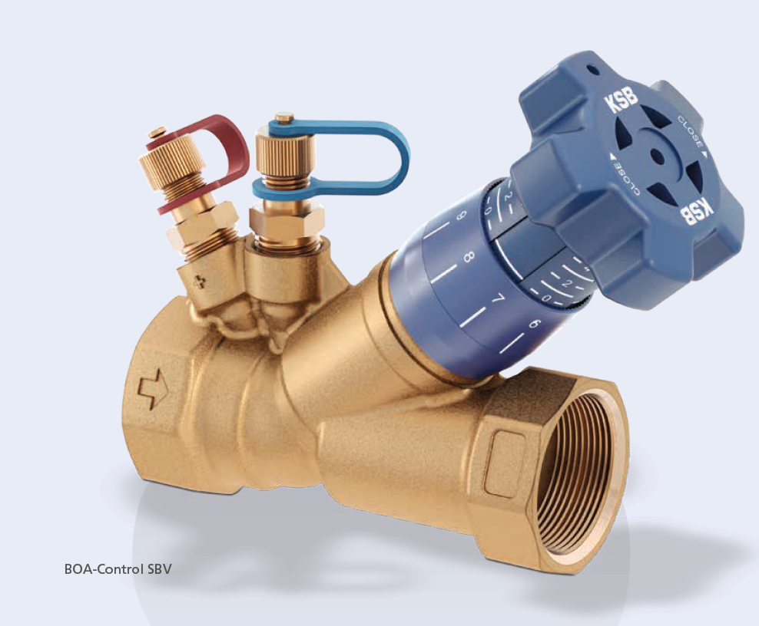

Photo: BOA-Control SBV balancing valve with female threaded ends (©KSB SE & Co. KGaA)

